PUCIT
Punjab University College of Information Technology



Software Engineering Department
Software Engineering

Submitted to | Dept. | Dated | Fall
Mam Sanam Ahmed | SE (Self – Support) | 12/25/2025 | 2024

SE Project Document

Submitted by
Muhammad Yahya Sohail | BSEF24A020
Ali Akbar Raza | BSEF24A021
Hasaan Abid | BSEF24A042
Muhammad Salman | BSEF24A004
Wasim Raja | BSEF24A023

Table of Contents
CHAPTER 1 4
Proposal Approval Signatures (FAC) 4
Signatures (Faculty Advisory Committee (FAC) 5
Contents 5
1-Project Title and abstract 6
2-Team Details 6
3-Problem Statement / Motivation 7
4-Project Objectives 7
5-System Overview 8
6-Development Methodology 8
Option A: Waterfall 8
Option B: Agile (Scrum) 8
7-Technology Stack 9
8-Project Timeline / Milestones 9
9-Market Fit / Commercial Potential 9
10-Competitor Analysis 9
CHAPTER 2 10
Planning 10
CHAPTER 3 15
Requirement Modeling 15
1-Use Case Diagram 15
2-Epics And User Stories: 16
EPICS 16
User Stories 17
Epic 1 17
Epic 3: 18
CHAPTER 4 19
1-Admin Dashboard 19
2-User 19
3- Browse Cars 20
4-Login Page 20
5-Available Cars 21
6-My Bookings 21
7-Profile Page 22
8-Create 22
9-Marketing Page 23
Entity Relationship Diagram (Chen Notation) 23
Entity Relationship Diagram (Crow Foot) 24
Class Diagram 25
CHAPTER 5 26
Technology Stack 26
GIT HUB Repository 26
Web App Link 26
CHAPTER 6 27
Car Rental System - Test Case Table (Basic) 27
Car Rental System - Detailed Test Case Descriptions 27
Table: TC-01 - Register / Login / Logout 27
Table: TC-02 - Edit Profile 28
Table: UC-03 - View Available Cars 28
Table: TC-04 - Search Cars 29
Table: TC-05 - Filter Cars 29
Table: TC-06 - View Car Details 30
Table: TC-07 - Book Car 30
Table: TC-08 - Cancel Booking 31
Table: TC-09 - Admin Login / Logout 31
Table: TC-10 - Manage Cars 31
Table: TC-11 - View Cars 32
Table: TC-12 - Manage Users 32
Table: TC-13 - Manage Bookings 33
Table: TC-14 - Mark Payment Status 33
Table: TC-15 - View Dashboard 34

CHAPTER 1
FYDP-DSE Proposal
Car Rental System (CRS)

Supervised by:
Prof. Sanam Ahmed
(Assistant Professor)

Proposal Approval Signatures (FAC)
We, the undersigned members of the assigned Faculty Advisory Committee (FAC), have reviewed the submitted project proposal. Based on our initial assessment, we acknowledge the group’s submission and confirm that the proposal has been evaluated for completeness and alignment with FYDP objectives.
Group ID: 4
Project title: Car Rental System (CRS)

Primary supervisor: Co-supervisor:

(Signature) ------------------- (Signature) -----------------

Signatures (Faculty Advisory Committee (FAC)

 | FAC member#1 | FAC member#2
Name
Signature

Head of FYDP Coordination Office:
(Signature)

Contents
1. Project Title and abstract 6
2. Team Details 6
3. Problem Statement / Motivation 7
4. Project Objectives 7
5. System Overview 8
6. Development Methodology 8
7. Technology Stack 9
8. Project Timeline / Milestones 9
9. Market Fit / Commercial Potential 9
10. Competitor Analysis 9

1-Project Title and abstract

Title: Smart Car Rental System
Abstract:
This project aims to develop a web-based car rental system that allows customers to search, book, and manage car rentals online. It will include an admin panel for managing cars, bookings, and users. The system will automate rental processes, reduce paperwork, and provide a user- friendly interface with Oracle as the backend database.

2-Team Details

List the details of all team members in the format below:

Name | Roll Number | Email | Role (Scrum Role /  Module Owner)
Muhammad Yahya  Sohail (Leader) | BSEF24A020 | bsef24a020@gmail.com | Module Owner /  Frontend
Muhammad Salman | BSEF24A004 | bsef24a004@gmail.com | Backend
Ali Akbar Raza | BSEF24A021 | bsef24a021@gmail.com | Database
Hassaan Abid | BSEF24A042 | bsef24a042@gmail.com | Scrum Role
Waseem Raja | BSEF24A023 | bsef24a023@gmail.com | Frontend

Clearly define each member’s responsibility (e.g., Product Owner, Scrum Master, Frontend Lead, Backend Lead, etc.) to ensure accountability and role clarity.

3-Problem Statement / Motivation

Manual car rental processes are time-consuming and prone to errors. Customers face difficulties in finding available cars quickly, while rental companies lack a centralized system for bookings and management. Our solution will digitize this process, improving efficiency and user experience.

4-Project Objectives

Following are the objectives of the project.
- Implement a secure authentication and user management module that allows both customers and administrators to sign up, log in, update their profiles, and securely manage their accounts using password encryption and form validation.
- Design and Develop a dynamic car listing and search feature that enables the admin to add, update, or delete car details, while allowing users to view, search, and filter available cars based on brand, type, or price.
- Build an efficient car booking system where users can select cars, specify rental dates, and confirm bookings with automatic availability checks, price calculation, and booking status updates (Pending, Confirmed, Completed, Cancelled).
- Enable users and admins to track booking history, allowing users to view their past and current bookings and administrators to monitor all bookings through a centralized system.
- Integrate a basic payment management system that displays total rental costs and allows the admin to mark bookings as paid or unpaid manually.
- Incorporate a notification system that sends automated email confirmations for successful bookings and cancellations, and notifies the admin of new bookings.
- Develop a comprehensive admin panel for managing users, cars, and bookings, with a dashboard displaying statistics such as total cars, users, bookings, and active rentals.
- Ensure system security and reliability by applying password encryption, restricting admin-only functionalities, validating input forms, and preventing duplicate bookings.
- Enhance user experience with features such as a car image gallery, car location filters, and simple analytics.

5-System Overview
The system will have two main modules: Customer Portal (search, booking, history) and Admin Panel (manage cars, users, bookings). Data will be stored in an Oracle database, and the app will run on a responsive web interface for desktop and mobile users.

6-Development Methodology
We would prefer AGILE (Incremental approach) for our Project but we will make a decision after consultation of our supervisor.

Option A: Waterfall

- Requirements Gathering – Collect and document all system requirements.
- Design – Prepare detailed design specifications (architecture, UI/UX mockups, database schema, etc.).
- Implementation – Develop the solution according to the design.
- Testing – Verify and validate the system’s functionality.
- Deployment & Maintenance – Deploy the solution and manage post-launch updates or bug fixes.

Option B: Agile (Scrum)

- Sprint-based Iterations – Divide the project into short, time-boxed development cycles.
- Backlog Management – Maintain a prioritized list of features and tasks.

- Scrum Roles – Assign roles (Product Owner, Scrum Master, Developers). Sprint Planning, Daily Standups, Sprint Review/Demo, Retrospective .

7-Technology Stack
List all the technologies, frameworks, and tools that will be used in different layers of your project:

Layer | Technologies/Tools
Frontend | HTML5 + CSS + Bootstrap 5
Backend | Node.js / Express.js
Database | MySQL
Dev Tools | GitHub

8-Project Timeline / Milestones

We will follow our supervisors’ instructions. Whatever task we are given and within whatever time frame, we will complete it accordingly.

9-Market Fit / Commercial Potential

Rental companies can use the system to streamline bookings, reduce manual work, and enhance customer satisfaction. The system can be scaled for commercial use by adding payment gateways.

10-Competitor Analysis

Existing platforms like ZoomCar, Turo or Easirent provide similar services but lack customization for small rental companies. Our system will offer an easy-to-use interface, simpler

CHAPTER 2

Planning
The following screenshots are taken from Jira Project Management software. They show how we managed our project using sprints, epics, user stories, and tasks. Jira was used to plan, track, and monitor sprint progress, assign tasks, and manage workflow throughout the development lifecycle.
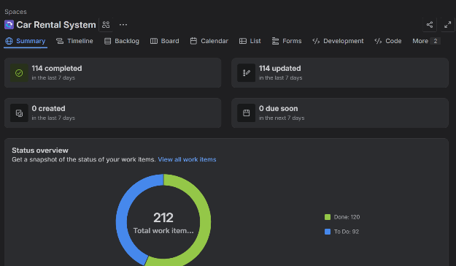

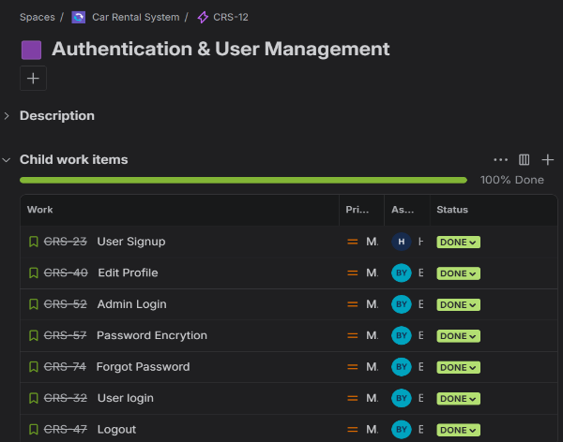

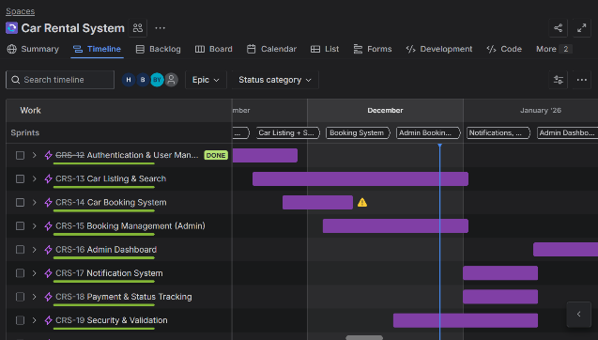

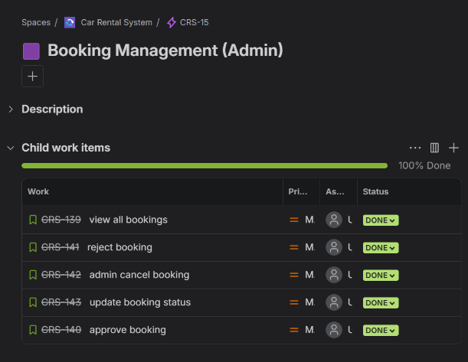

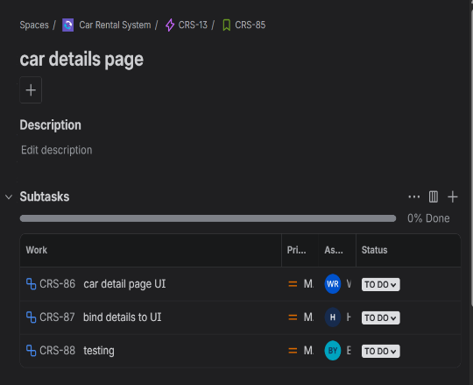
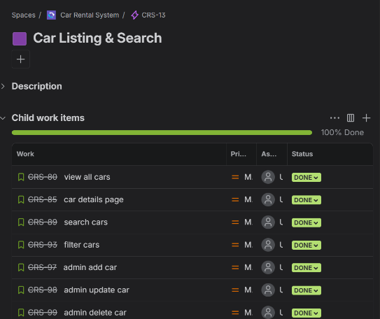

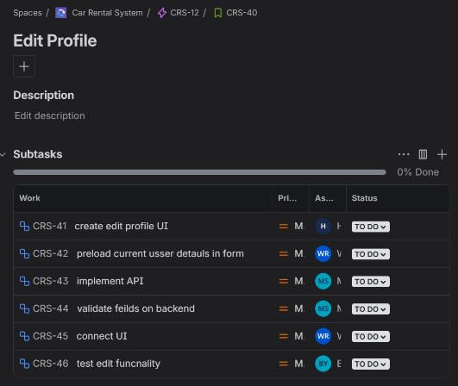

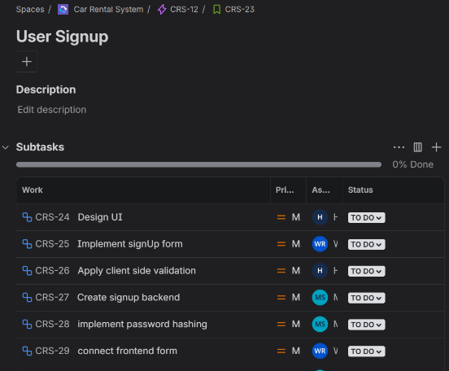

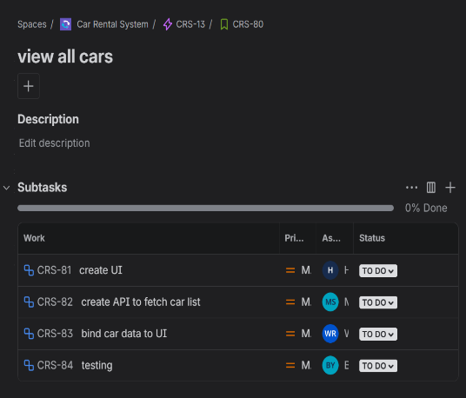

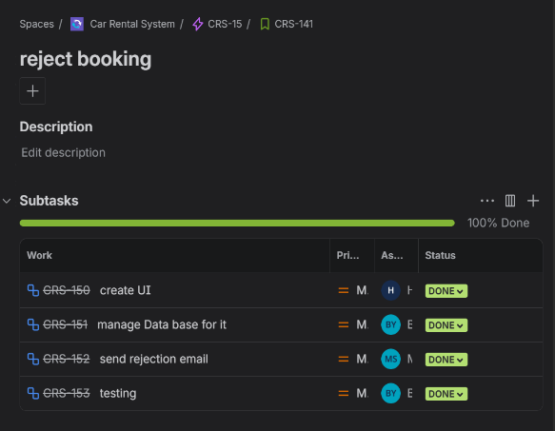

CHAPTER 3

Requirement Modeling

1-Use Case Diagram:

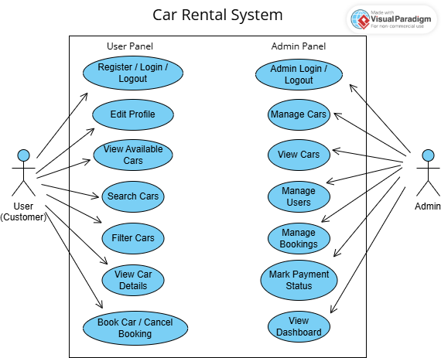

2-Epics And User Stories:

EPICS

Epic ID | Epic Name | Objective
E1 | Authentication & User Management | Allow customers and admins to securely register, log in/out, and manage their profiles.
E2 | Car Listing & Search | Enable users to browse, search, and filter available cars with detailed information.
E3 | Car Booking System | Facilitate booking, cancellation, and price calculation based on rental dates
E4 | Booking Management  (admin) | Allow admin to approve,  reject, or cancel bookings and monitor system activity.
E5 | Admin Dashboard | Display system stats: total cars, users, and bookings for monitoring and reporting.
E6 | Notification System | Provide email confirmations and alerts for bookings and cancellations.
E7 | Payment & Status Tracking | Enable admin to mark  payments as paid/unpaid and  view booking payment status.
E8 | Security & Validation | Ensure data integrity, prevent double bookings, and protect credentials.

User Stories

User Stories of Two Core Epics

Epic 1: Authentication & User Management

Objective: Provide secure login/signup for users and admin with editable profiles and session
handling.

User Stories ID | As a | I want to | So that
US-1.1 | User | Sign up with my details | I can create a  new account
US-1.2 | User | Log in with my credentials | I can access my  dashboard
US-1.3 | User | Edit my profile | I can update my personal info
US-1.4 | User | Log out | I can end my  session securely
US-1.5 | Admin | Login to Admin | I can manage  panel system feature

Epic 3: Car Booking System

Objective: Allow users to book cars with start/end dates, automatic price calculation, and
availability check.

User Stories ID | As a | I want to | So that
US-3.1 | User | Select a car and  View details | I can decide  whether to book  it.
US-3.2 | User | Choose rental  dates | I can plan the  duration
US-3.3 | System | Check car  availability | Prevent double  booking
US-3.4 | User | View price before  confirming | I know total cost
US-3.5 | User | Confirm booking | Finalize my  reservation
US-3.6 | User | Cancel booking  before start | I can modify my  plans
US-3.7 | Admin | View all bookings | I can manage reservations

CHAPTER 4

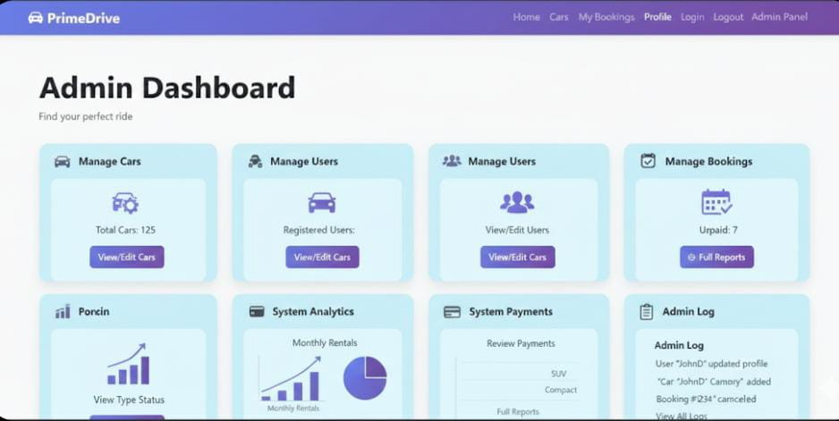
1-Admin Dashboard

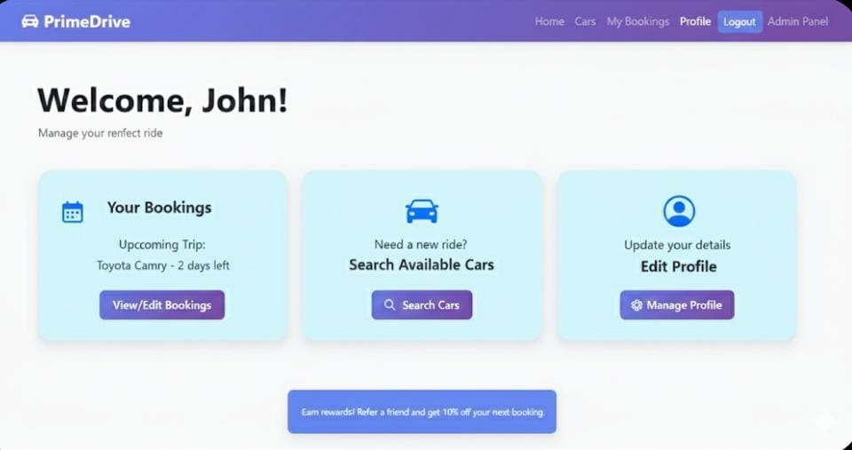
2-User Dashboard

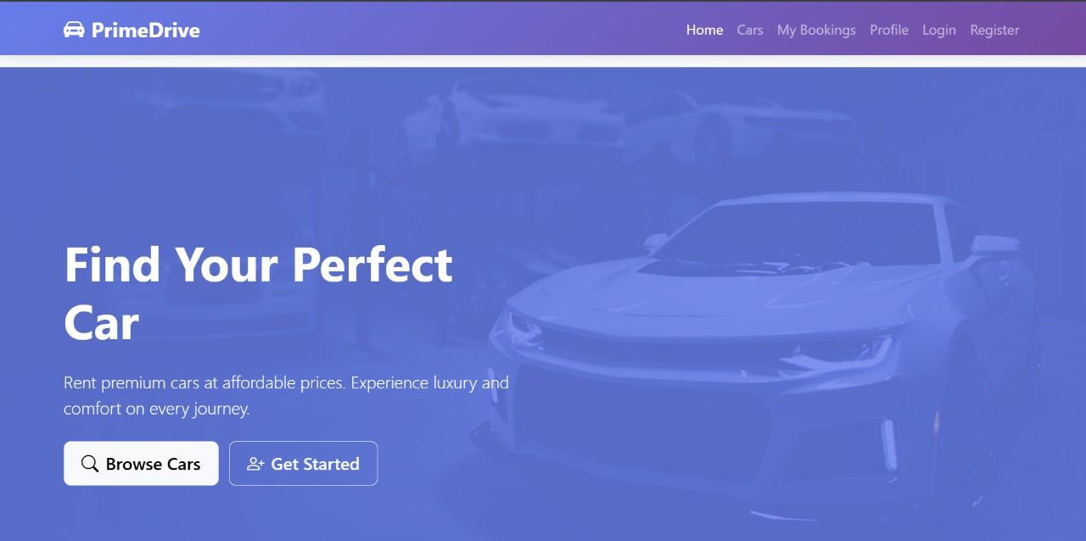
3- Browse Cars

4-Login Page
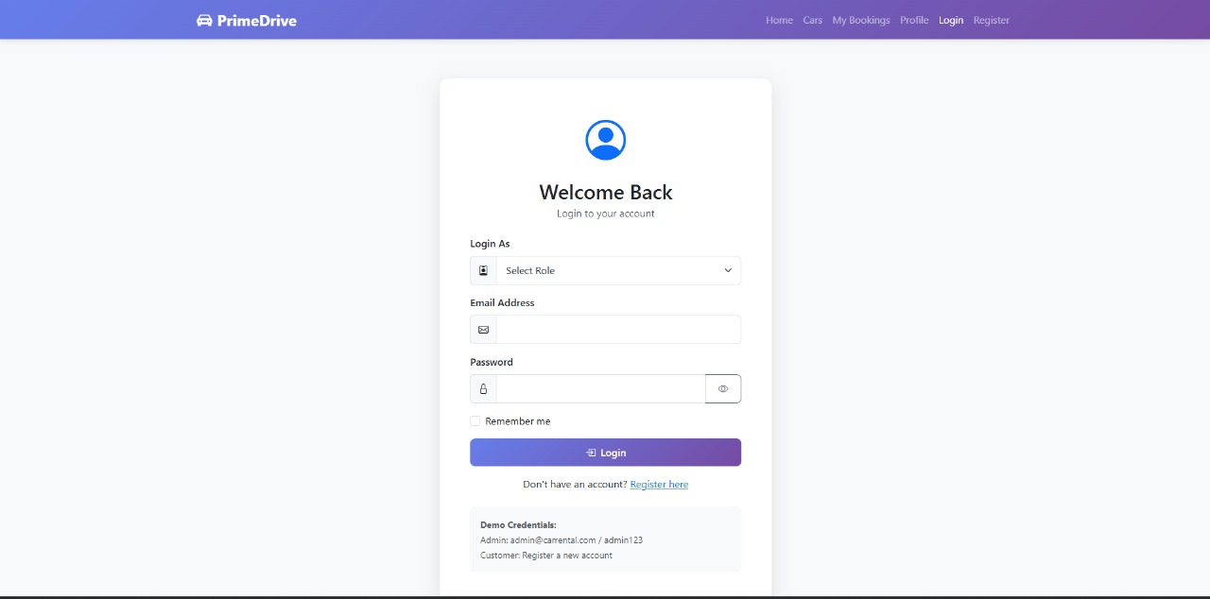

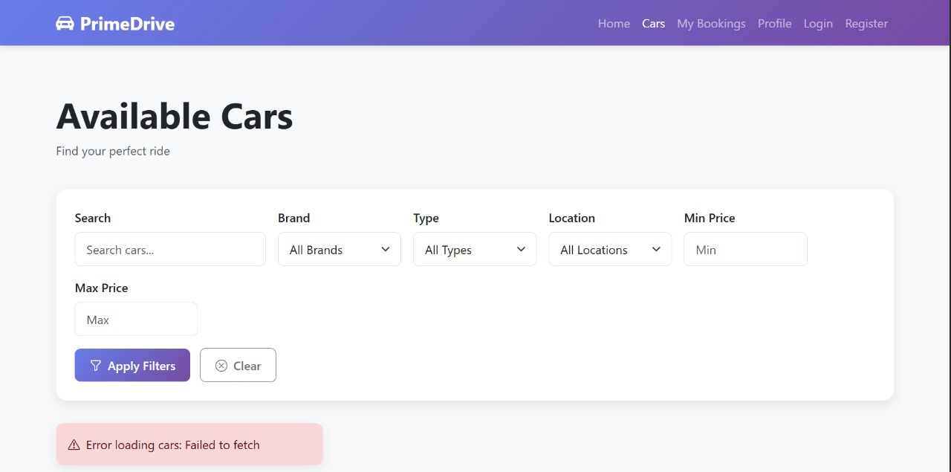
5-Available Cars

6-My Bookings
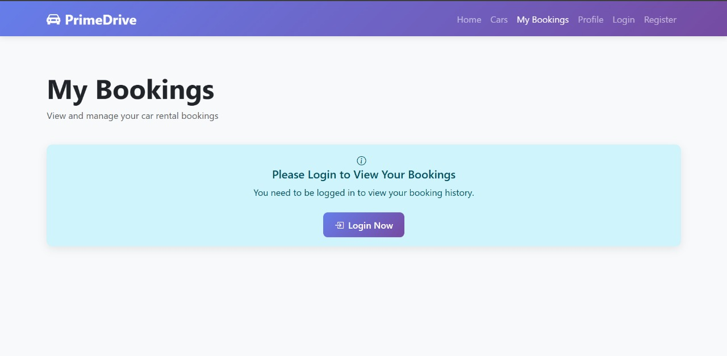

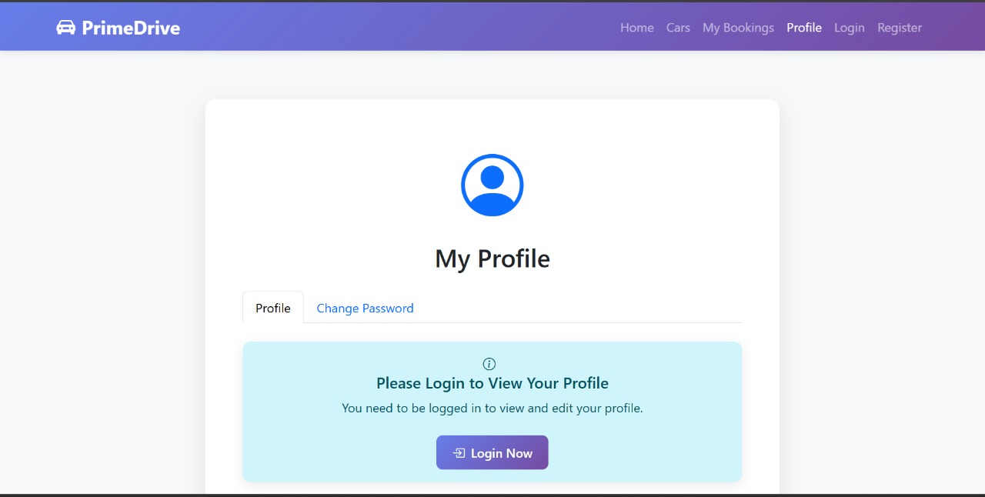
7-Profile Page

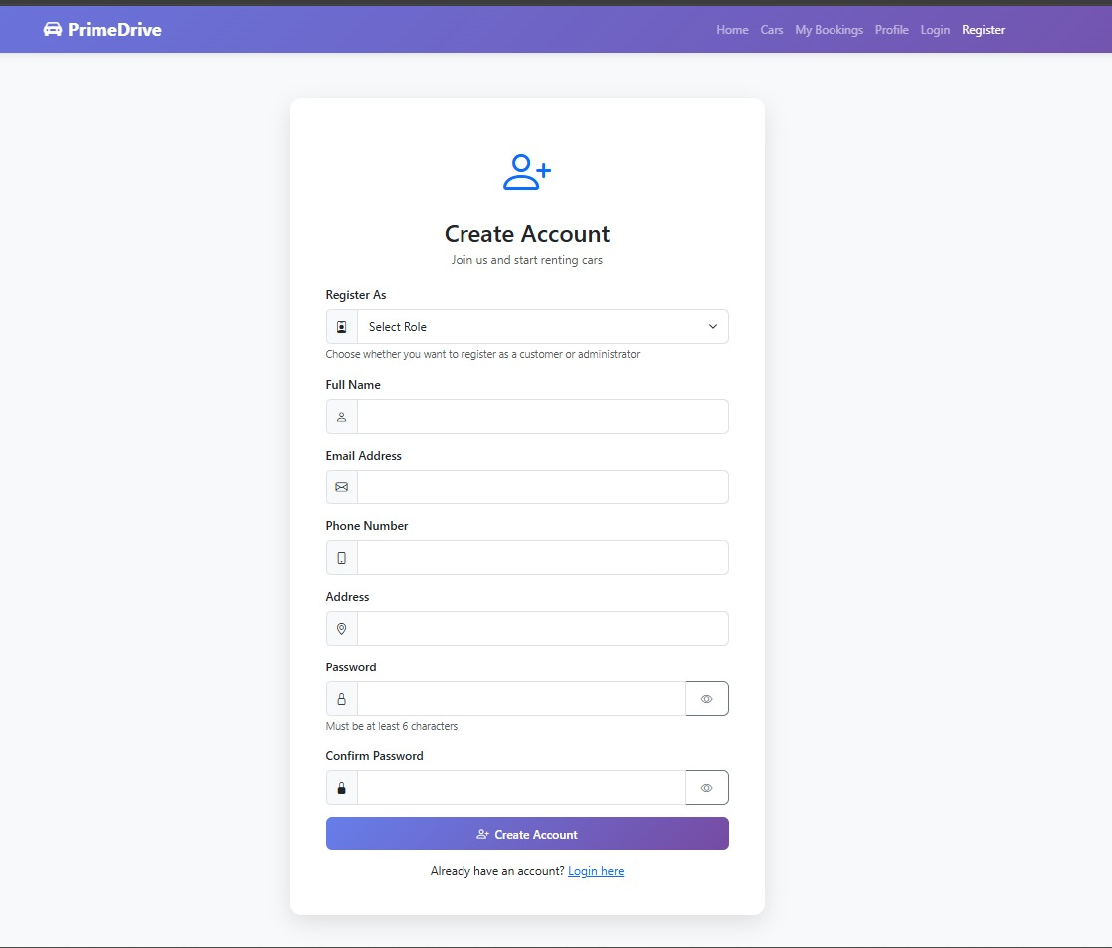
8-Create Account

9-Marketing Page
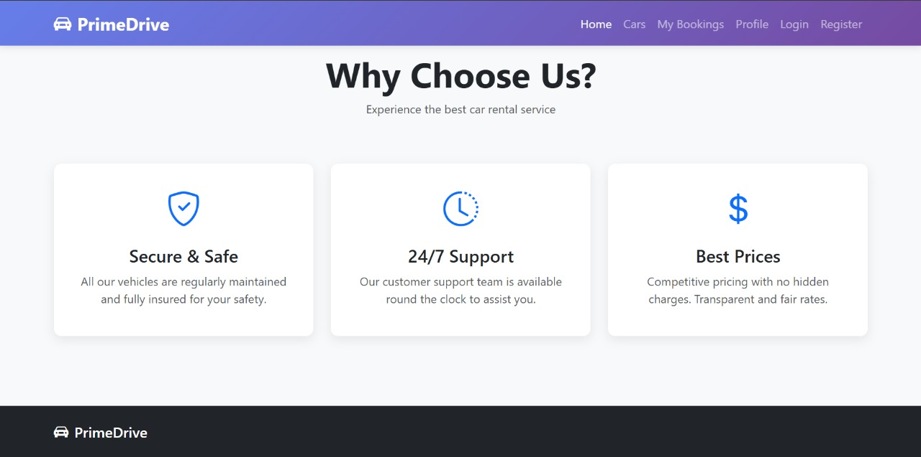

Entity Relationship Diagram (Chen Notation)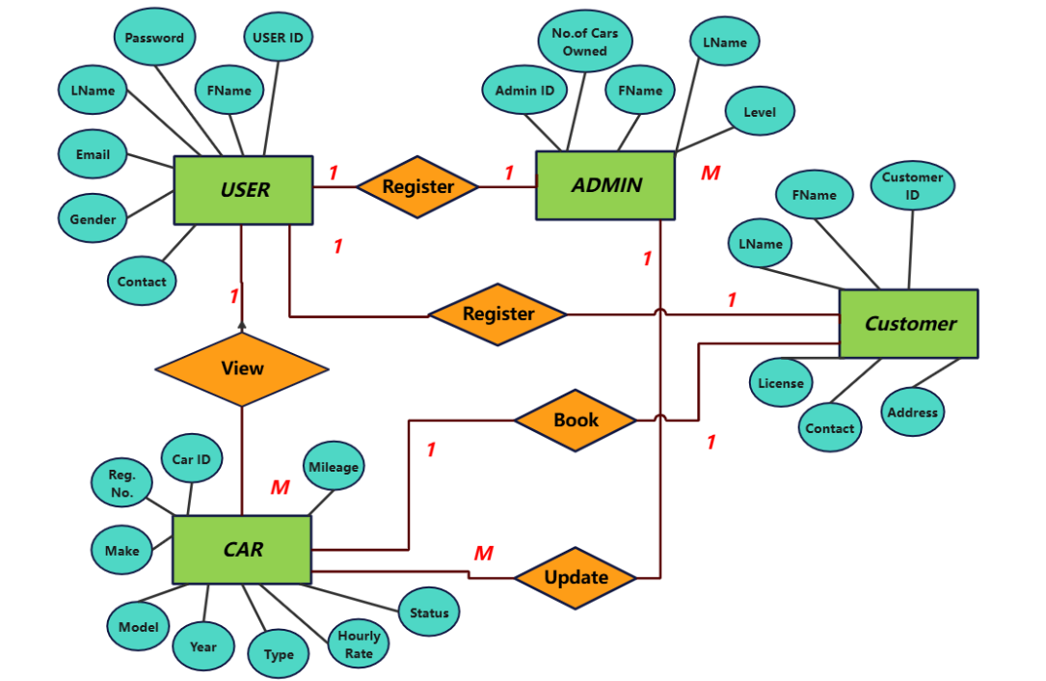

Entity Relationship Diagram (Crow Foot)

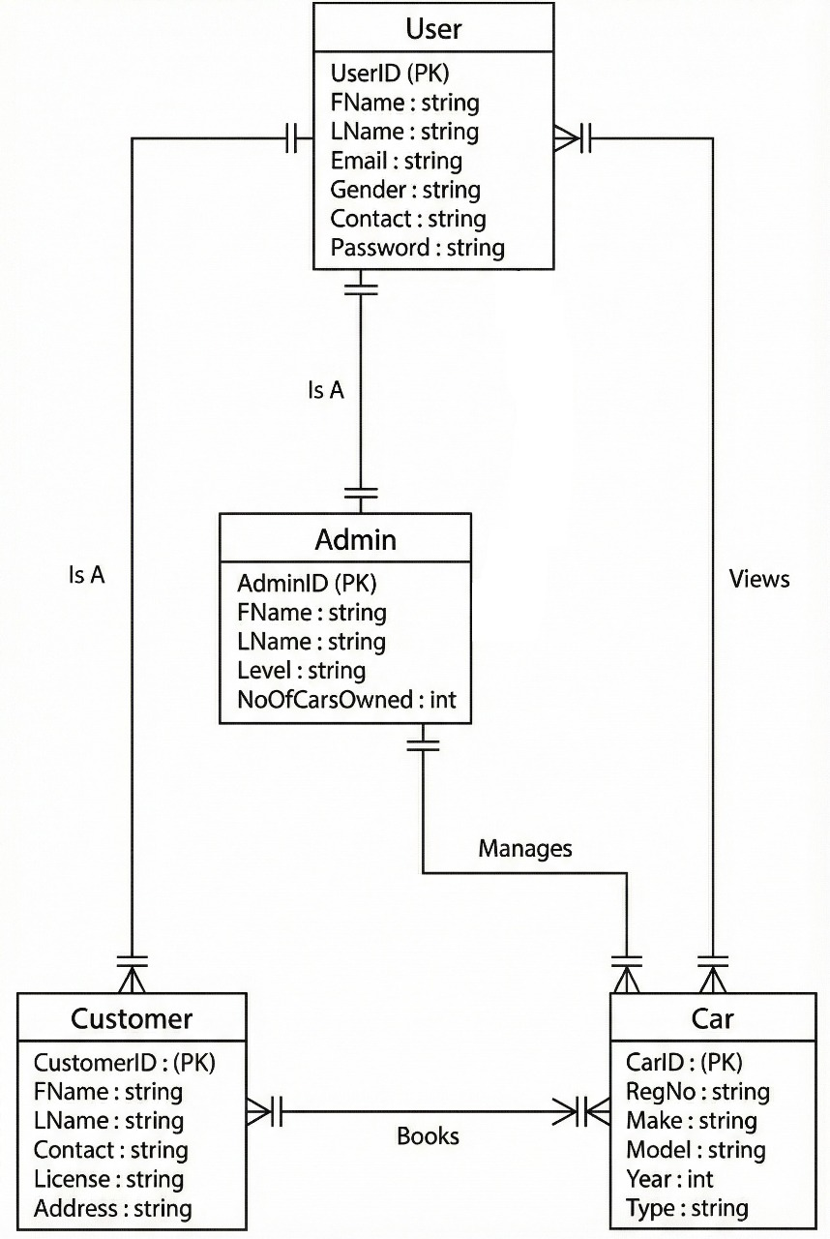

Class Diagram

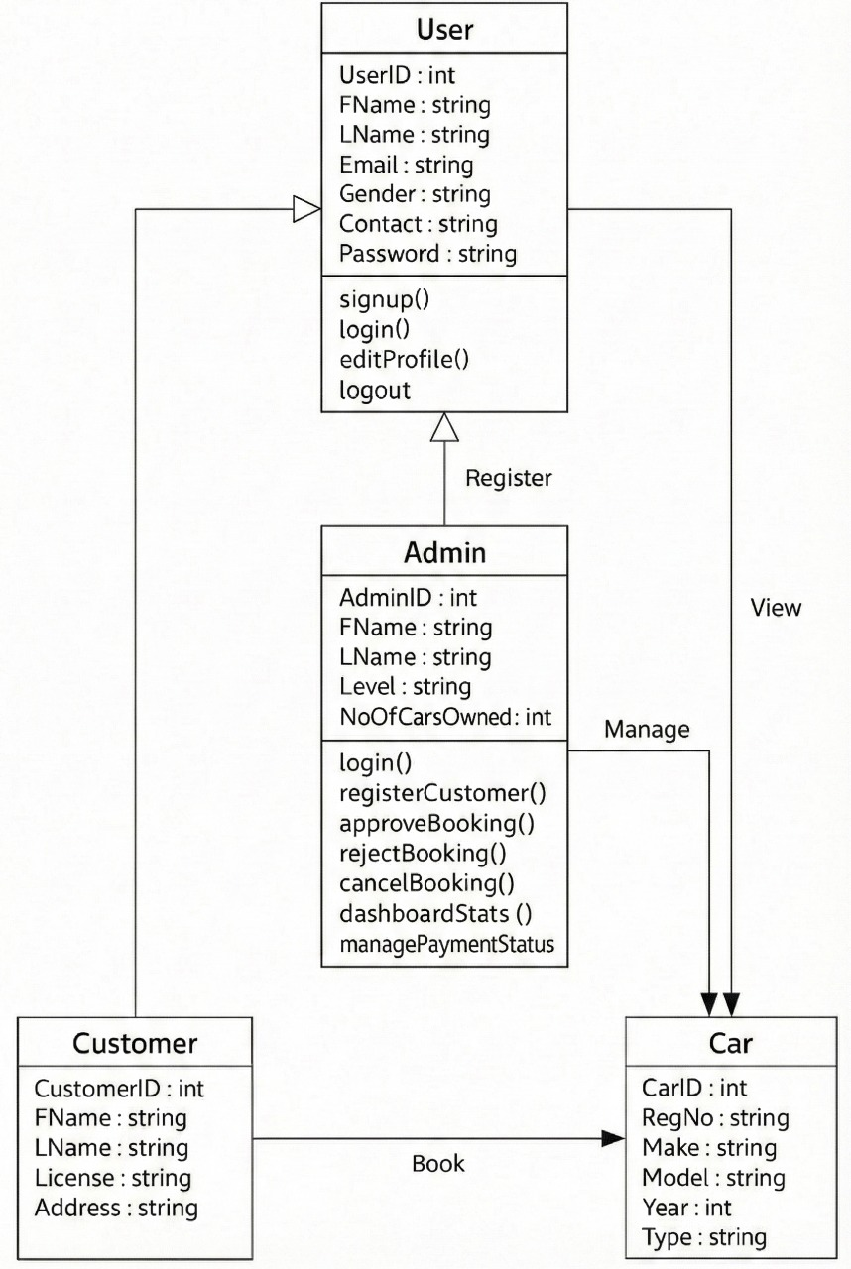

CHAPTER 5

Technology Stack

Layer | Technologies/Tools
Frontend | HTML + CSS + Bootstrap 5
Backend | Node.js / Express.js
Database | MySQL
Dev Tools | GitHub

GIT HUB Repository

https://github.com/M-Yahya-Sohail/PrimeDrive-Project

Web App Link

https://primedrive-pk.netlify.app/

CHAPTER 6

Car Rental System - Test Case Table (Basic)
Test Case ID | Use Case Name | Actor | Status
TC-01 | Register / Login / Logout | User | Done
TC-02 | Edit Profile | User | Done
TC-03 | View Available Cars | User | Done
TC-04 | Search Cars | User | Done
TC-05 | Filter Cars | User | Done
TC-06 | View Car Details | User | Done
TC-07 | Book Car | User | Done
TC-08 | Cancel Booking | User | Done
TC-09 | Admin Login / Logout | Admin | Done
TC-10 | Manage Cars (Add / Edit / Delete) | Admin | Done
TC-11 | View Cars | Admin | Done
TC-12 | Manage Users | Admin | Done
TC-13 | Manage Bookings | Admin | Done
TC-14 | Mark Payment Status | Admin | Done

Car Rental System - Detailed Test Case Descriptions

Table: TC-01 - Register / Login / Logout
Test Case ID | TC-01
Test Case Name | Register / Login / Logout
Primary Actor | User
Secondary Actor | System
Description | Allows a user to create an account, log in to access the system, or log out securely.
Trigger | The user decides to register a new account or access the system.
Pre-Condition | The system is operational, and the user has an internet connection.
Post-Condition | The user is successfully logged in or out of the system.
Success Scenario | The user’s credentials are verified and access is granted or terminated as requested.
Abort Scenario | The system denies access due to invalid credentials or connection failure.

Table: TC-02 - Edit Profile
Test Case ID | TC-02
Test Case Name | Edit Profile
Primary Actor | User
Secondary Actor | System
Description | Enables a user to update their personal information such as name, email, and contact details.
Trigger | The user chooses to modify their profile information.
Pre-Condition | The user must be logged into the system.
Post-Condition | The user’s profile is successfully updated in the database.
Success Scenario | The system stores the updated information and confirms changes.
Abort Scenario | The profile update fails due to validation or database errors.

Table: UC-03 - View Available Cars
Use Case ID | UC-03
Use Case Name | View Available Cars
Primary Actor | User
Secondary Actor | System
Description | Allows the user to view a list of cars currently available for rent.
Trigger | The user navigates to the car listings page.
Pre-Condition | The system must contain data on available cars.
Post-Condition | The system displays all cars available for booking.
Success Scenario | Available cars are fetched and shown to the user.
Abort Scenario | No cars are available or a system error prevents display.

Table: TC-04 - Search Cars
Test Case ID | TC-04
Test Case Name | Search Cars
Primary Actor | User
Secondary Actor | System
Description | Enables the user to search for cars by name, brand, or type.
Trigger | The user enters search criteria in the search bar.
Pre-Condition | The system must have car data stored in the database.
Post-Condition | The search results are displayed according to the criteria.
Success Scenario | Relevant cars are shown based on search parameters.
Abort Scenario | No cars match the criteria or a search error occurs.

Table: TC-05 - Filter Cars
Test Case ID | TC-05
Test Case Name | Filter Cars
Primary Actor | User
Secondary Actor | System
Description | Allows the user to filter cars by price or type for easier browsing.
Trigger | The user selects filter options from the interface.
Pre-Condition | The system has available cars with valid attributes.
Post-Condition | The filtered list of cars is displayed successfully.
Success Scenario | Cars meeting the selected filter criteria are shown.
Abort Scenario | The filter process fails or returns no results.

Table: TC-06 - View Car Details
Test Case ID | TC-06
Test Case Name | View Car Details
Primary Actor | User
Secondary Actor | System
Description | Provides detailed information about a selected car including brand, price, and description.
Trigger | The user selects a specific car from the list.
Pre-Condition | The system stores detailed records for each car.
Post-Condition | The car details are displayed accurately to the user.
Success Scenario | The system retrieves and shows the requested car details.
Abort Scenario | Details cannot be displayed due to missing data or system error.

Table: TC-07 - Book Car
Test Case ID | TC-07
Test Case Name | Book Car
Primary Actor | User
Secondary Actor | System
Description | Allows the user to book a car for specific dates with automatic price calculation.
Trigger | The user confirms booking after selecting the car and dates.
Pre-Condition | The user must be logged in and the car must be available.
Post-Condition | The booking is recorded and confirmation is sent to the user.
Success Scenario | The booking record is stored with calculated price and dates.
Abort Scenario | The booking fails due to unavailability or system error.

Table: TC-08 - Cancel Booking
Test Case ID | TC-08
Test Case Name | Cancel Booking
Primary Actor | User
Secondary Actor | System
Description | Enables the user to cancel a confirmed booking before the start date.
Trigger | The user initiates the cancellation from their booking history.
Pre-Condition | The user must have an existing active booking.
Post-Condition | The booking status is updated to 'Cancelled'.
Success Scenario | The system processes the cancellation successfully.
Abort Scenario | Cancellation fails due to policy restrictions or system issue.

Table: TC-09 - Admin Login / Logout
Test Case ID | TC-09
Test Case Name | Admin Login / Logout
Primary Actor | Admin
Secondary Actor | System
Description | Allows the administrator to log into the system or log out after use.
Trigger | The administrator attempts to access the admin panel.
Pre-Condition | The admin account must exist in the system database.
Post-Condition | The admin is authenticated and gains or ends access.
Success Scenario | The system validates admin credentials and manages the session.
Abort Scenario | The login attempt fails due to invalid credentials or server error.

Table: TC-10 - Manage Cars
Test Case ID | TC-10
Test Case Name | Manage Cars
Primary Actor | Admin
Secondary Actor | System
Description | Enables the administrator to add, update, or remove car details from the system.
Trigger | The administrator decides to manage car records.
Pre-Condition | The admin must be logged into the system.
Post-Condition | The car records are successfully updated in the database.
Success Scenario | The system processes and saves car management actions.
Abort Scenario | The car management action fails due to validation or database issues.

Table: TC-11 - View Cars
Test Case ID | TC-11
Test Case Name | View Cars
Primary Actor | Admin
Secondary Actor | System
Description | Allows the administrator to view all cars listed in the system.
Trigger | The administrator selects the option to view cars.
Pre-Condition | The system contains car records.
Post-Condition | All car records are displayed to the administrator.
Success Scenario | The system retrieves and displays all car data.
Abort Scenario | No car records are available or data retrieval fails.

Table: TC-12 - Manage Users
Test Case ID | TC-12
Test Case Name | Manage Users
Primary Actor | Admin
Secondary Actor | System
Description | Allows the administrator to view and manage registered user accounts.
Trigger | The administrator chooses to view or modify user records.
Pre-Condition | The admin must be logged into the system.
Post-Condition | The user data is successfully updated or displayed.
Success Scenario | The system processes user management actions accurately.
Abort Scenario | Management fails due to validation or permission errors.

Table: TC-13 - Manage Bookings
Test Case ID | TC-13
Test Case Name | Manage Bookings
Primary Actor | Admin
Secondary Actor | System
Description | Allows the administrator to view, approve, reject, or cancel bookings made by users.
Trigger | The administrator accesses the booking management module.
Pre-Condition | The system must have booking data stored.
Post-Condition | The booking statuses are updated as per admin actions.
Success Scenario | The system processes booking approvals or rejections successfully.
Abort Scenario | The update fails due to missing data or system issue.

Table: TC-14 - Mark Payment Status
Test Case ID | TC-14
Test Case Name | Mark Payment Status
Primary Actor | Admin
Secondary Actor | System
Description | Allows the administrator to mark bookings as Paid or Unpaid.
Trigger | The administrator selects a booking to update payment status.
Pre-Condition | The booking must exist in the system.
Post-Condition | The payment status is successfully updated.
Success Scenario | The system records and confirms payment status update.
Abort Scenario | The update fails due to incorrect booking reference or system issue.

Table: TC-15 - View Dashboard
Test Case ID | TC-15
Test Case Name | View Dashboard
Primary Actor | Admin
Description | Allows the administrator to view system statistics including total cars, users, and bookings.
Trigger | The administrator accesses the dashboard interface.
Pre-Condition | The admin must be logged into the system.
Post-Condition | Dashboard metrics are displayed accurately.
Success Scenario | The system generates and shows analytical data.
Abort Scenario | Dashboard data cannot be loaded due to system error.

